

Department of Systems

School of Computer Science (SOCS)

UNIVERSITY OF PETROLEUM & ENERGY STUDIES,

DEHRADUN - 248007, Uttarakhand

**Final Report**

**Shoot’n Shield**

**Date: 01.05.2024**

Prepared by:

|  |  |  |  |
| --- | --- | --- | --- |
| **S. No** | **Students Name** | **Sap Id** | **Specialization** |
| 1. | Shahan Ali | 500097227 | B.Tech. CSE (Spl.GG) |

**Mr. Alind(Mentor)**

**Index**

|  |  |  |
| --- | --- | --- |
| S.No | Heading Outline | Page no. |
| 1 | Title of the project | 3 |
| 2 | Introduction | 3 |
| 3 | Background Information | 3 |
| 4 | Future Implication | 3 |
| 6 | Problem Statement | 4 |
| 7 | Motivation | 4 |
| 8 | Graphical User Interface | 6 |
| 9 | SWOT Analysis | 9 |
| 10 | References | 10 |

# **Project Title**

**Shoot’n Shield**

# **Introduction**

# The 2D game project aims to address the aforementioned issues by providing an engaging and dynamic gaming experience through the implementation of randomized enemy generation and interactive shooting mechanics. The game offers players the opportunity to test their reflexes and strategic thinking in a fast-paced environment where each playthrough presents unique challenges.

# **Background Information**

* Game Concept: The game revolves around a player-controlled character tasked with shooting down randomly generated enemies to earn points. These enemies pose a threat to the player's health, creating a sense of urgency and tension.
* Game Mechanics: Players move the faces being on the same point and shoot projectiles vertically to eliminate enemies. The speed and frequency of enemy spawns increase as the game progresses, adding to the difficulty level.
* Scoring System: Points are awarded to the player based on the number of enemies successfully defeated. Additionally, bonus points may be earned for consecutive enemy hits or achieving certain milestones within the game.
* Health and Game Over: The player's health gradually decreases upon enemy contact. Once the player's health reaches zero, the game ends, and the final score is displayed. Players have the option to restart the game to beat their previous high score.
* Randomization and Replayability: The game leverages randomization algorithms to generate diverse enemy patterns, ensuring each gameplay session feels fresh and unpredictable. This feature enhances replayability and encourages players to strive for higher scores with each attempt.

## **Future Implication**

* Enhanced Player Engagement: By continually refining the game's mechanics and introducing new features, future iterations of the project aim to further enhance player engagement and immersion. This may include incorporating feedback mechanisms, adding customizable player avatars, or introducing multiplayer modes to foster social interaction.
* Expansion of Gameplay Elements: Future updates could introduce additional gameplay elements such as power-ups, special abilities, or environmental obstacles to diversify the gaming experience. These enhancements would add layers of strategy and complexity, appealing to a broader audience of players.
* Integration of Advanced AI: As technology advances, integrating more sophisticated artificial intelligence algorithms into enemy behavior can create more challenging and dynamic gameplay scenarios. Enemies could adapt their tactics based on player performance, providing a more personalized and immersive gaming experience.
* Cross-Platform Compatibility: To reach a wider audience, future developments may focus on optimizing the game for various platforms and devices, including mobile phones, tablets, and gaming consoles. This would require adapting the user interface and controls to suit different screen sizes and input methods while ensuring a consistent gaming experience across platforms.
* Community Engagement and User-Generated Content: Establishing a vibrant community around the game can lead to the creation of user-generated content, such as custom levels, mods, or fan art. Embracing user creativity and fostering community collaboration can extend the game's lifespan and cultivate a dedicated fan base.
* Educational Applications: Beyond entertainment, the game project could have educational implications by incorporating elements of computer science, mathematics, or problem-solving skills into gameplay. Future iterations may explore gamified learning experiences, allowing players to develop and practice real-world skills in a fun and interactive way.
* Potential for Monetization: With a solid foundation in place, future iterations of the project may explore monetization opportunities such as in-game purchases, ad placements, or premium content expansions. Careful consideration of monetization strategies can help sustain the project's development and support ongoing innovation.

## **Problem Statement**

* Lack of Engaging 2D Games: Traditional 2D games often lack dynamic elements that keep players engaged over time.
* Absence of Randomized Challenges: Many 2D games rely on pre-defined levels or patterns, leading to repetitive gameplay experiences.
* Limited Player Interaction: Players may feel detached from the game due to a lack of meaningful interaction and variability in gameplay mechanics.

## **6. Motivation**

* Passion for Game Development: The primary motivation behind the project stems from a shared passion for game development among the team members. Each member brings their unique skills and expertise to the table, driven by a common goal of creating an immersive and enjoyable gaming experience.
* Creative Expression: Game development provides a creative outlet for expressing ideas, storytelling, and artistic vision. The project serves as a canvas for exploring innovative gameplay mechanics, visual aesthetics, and narrative elements, allowing the team to unleash their creativity and push the boundaries of what's possible in gaming.
* Desire to Entertain and Engage: At its core, the project aims to entertain and engage players, offering them an escape from the mundane realities of everyday life. Whether it's providing a brief respite during a hectic day or sparking moments of joy and excitement, the game seeks to leave a lasting impression on its audience.
* Challenge and Growth: Game development presents a myriad of technical and creative challenges that inspire continuous learning and growth. From coding complex game mechanics to designing captivating visuals and soundscapes, each obstacle encountered throughout the development process serves as an opportunity for personal and professional development.
* Community Impact: Beyond personal fulfillment, the project aspires to make a positive impact on the gaming community. By creating a game that resonates with players and fosters a sense of community and camaraderie, the team hopes to contribute to the vibrant and diverse landscape of indie game development.
* Entrepreneurial Spirit: For some team members, the project represents an opportunity to channel their entrepreneurial spirit and turn their passion for game development into a viable business venture. While success is never guaranteed in the competitive gaming industry, the journey of building and launching a game is as rewarding as the destination itself.
* Legacy and Recognition: Lastly, the desire to leave a mark and be recognized for their contributions drives the team to pour their hearts and souls into the project. Whether it's receiving accolades from peers and players or simply knowing that their work has touched the lives of others, the pursuit of recognition serves as a powerful motivator throughout the game development journey.

## **7.Screenshots**



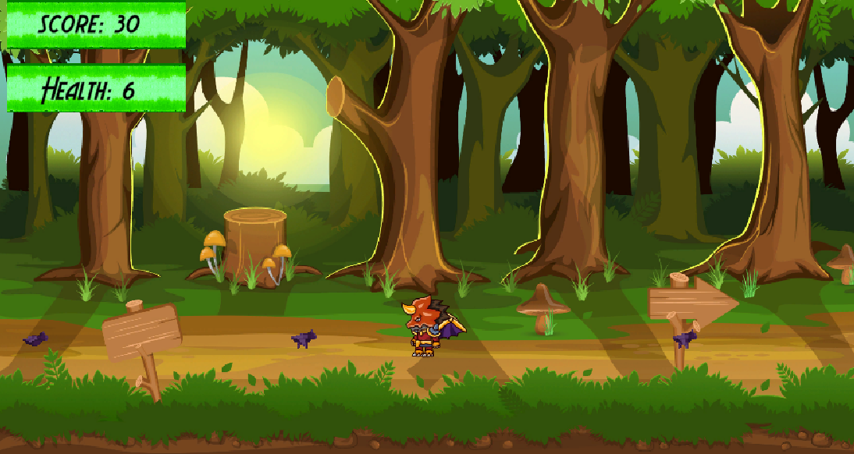

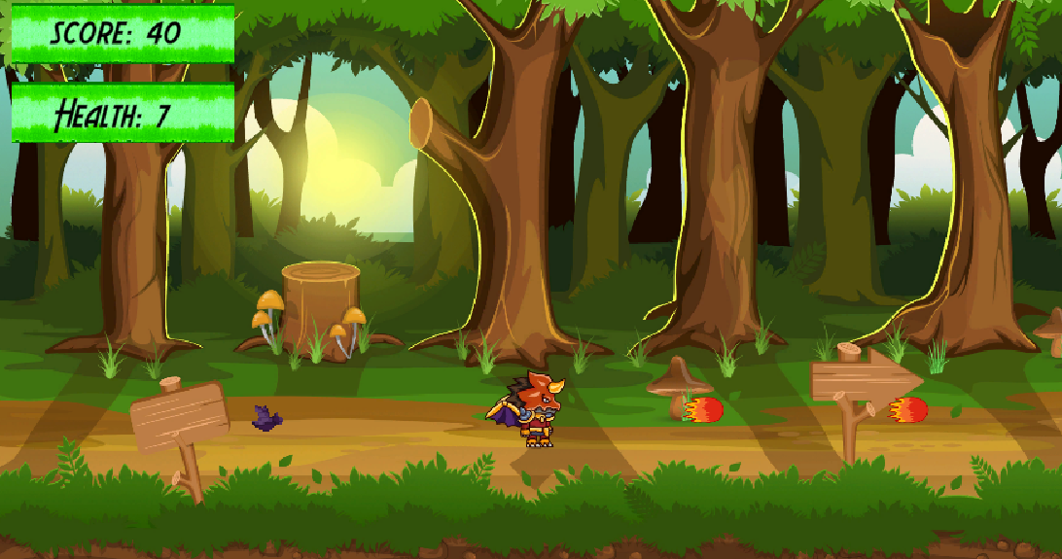

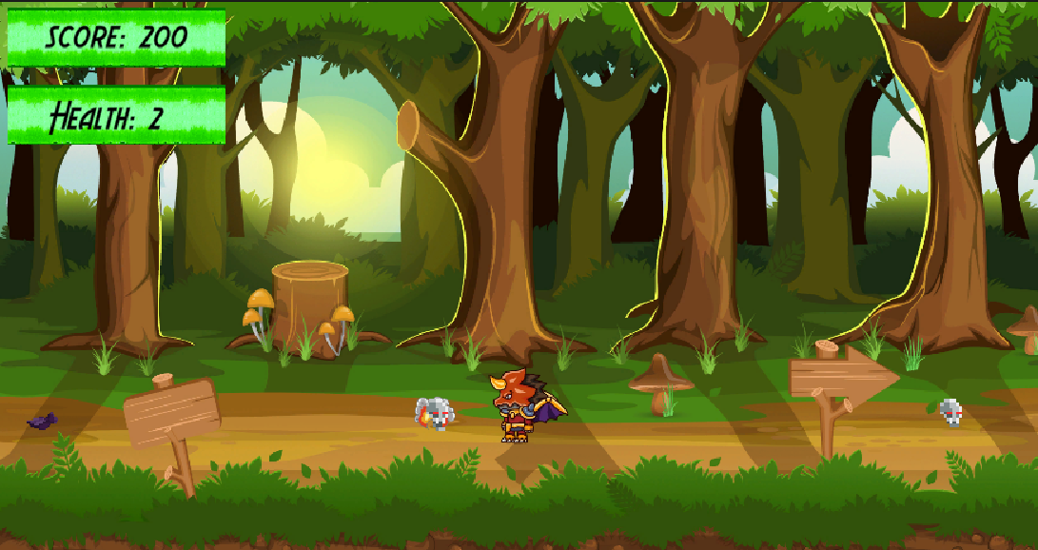

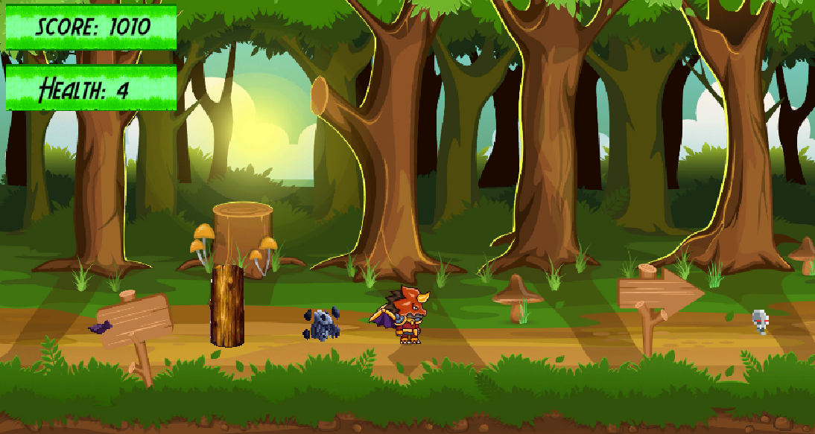



## **8.SWOT Analysis**

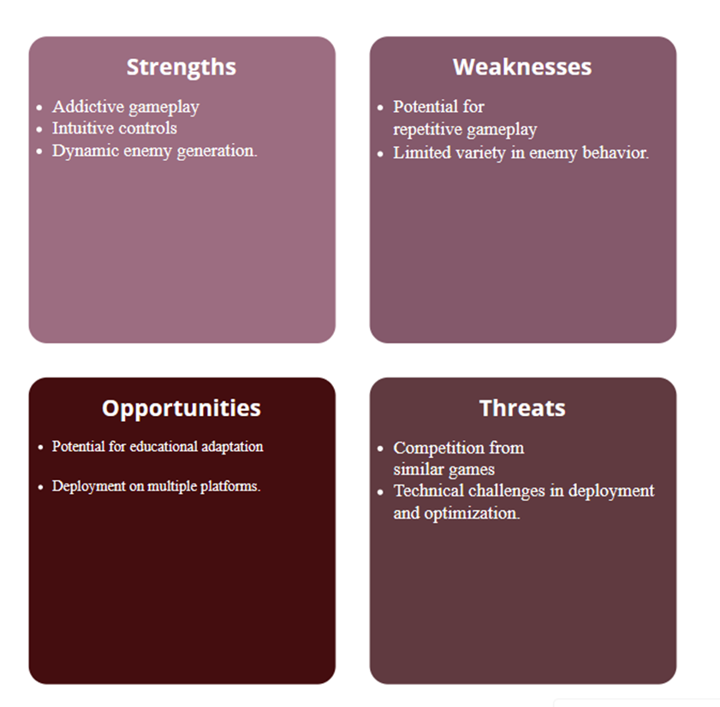

## **9. References**

https://unity.com/  
https://assetstore.unity.com/  
https://www.geeksforgeeks.org/unity-books-for-game-development/  
https://unity.com/solutions/indie-innovation  
https://flylib.com/books/en/2.208.1.86/1/  
https://unity.com/open-projects  
https://en.wikipedia.org/wiki/Unity_(game_engine)